Recommended learning: <https://www.coursera.org/learn/machine-learning>

ToDo:

* Add anomaly detection – seems very useful

Machine Learning (ML) is becoming more and more accessible with numerous quality free courses, cheap computing resources, commercial-grade tools like Google’s Tensorflow and Microsoft’s Cognitive Toolkit that are available to anyone for free.

In one sentence – ML is just really fancy curve fitting.

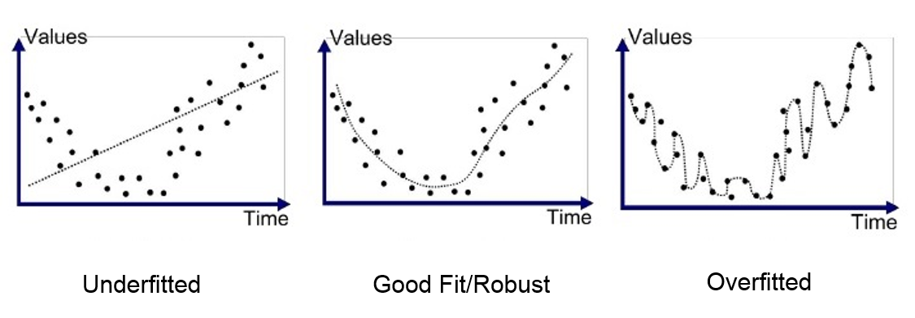

The original work by Ci Rong implemented a linear classifier, where specific frequency values that were observed to change the most between sharp and worn tool were separated by a simple linear boundary.



The results were promising, however data needed to be expertly processed and thoroughly understood.

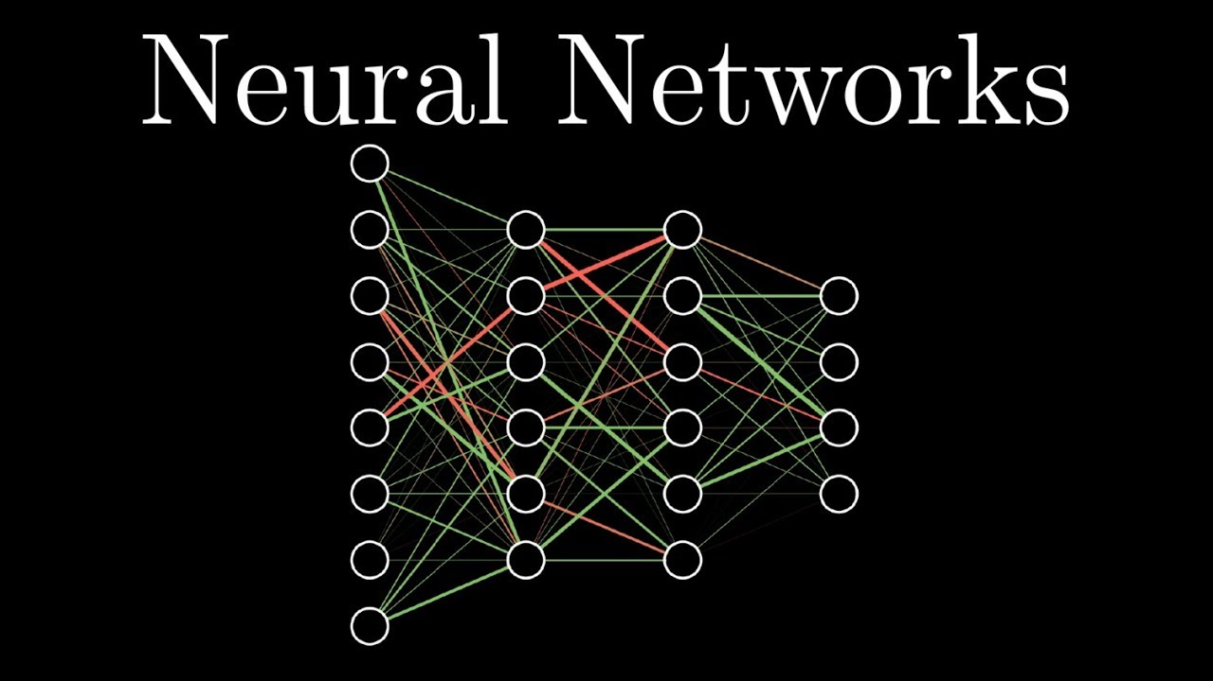

Neural Networks are more computationally intensive, but they may require less user input. They allow calculation of complex non-linear data relationships without having to manually select or deeply analyse any features from the data set.

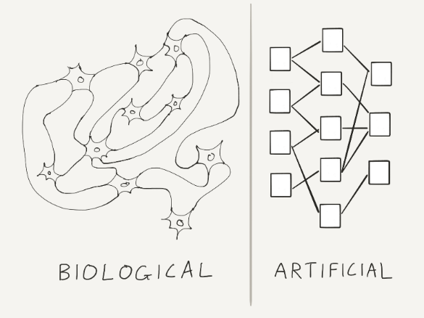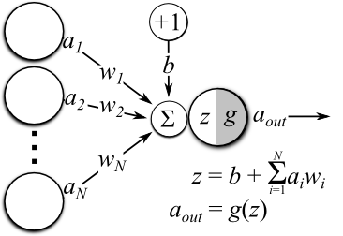

In supervised ML, the user must collect data with a known outcome to train the NN model. A Neural Network ‘learns’ by adjusting the weights/coefficients associated with inputs to its nodes. In this way data that varies without effect on the desired metric is given small coefficients and doesn’t skew the results.

The training algorithm is initialized with random non-symmetric weights. Then real data is used to calculate the outcome. The difference between initial network computation and real observed condition from data is used to adjust weights (each weight should be slightly different so the network can ‘understand’ better which neuron node has created most error).

Each training iteration the weights change. The error is can be visualized as a function of weights. In this sense, we need to minimize the error by looking at the gradient of such plot and try to descend into global minima. J is error, Thetas are weights:

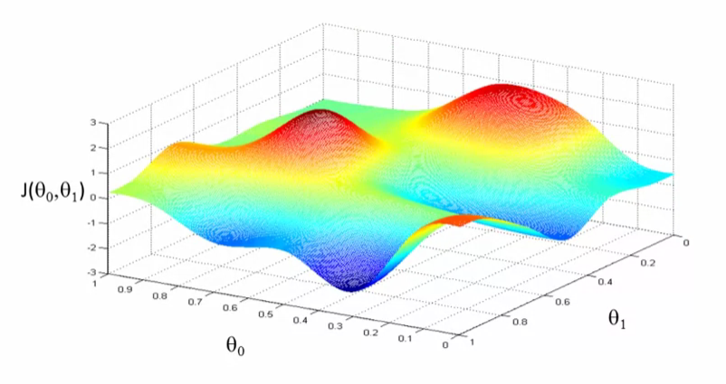

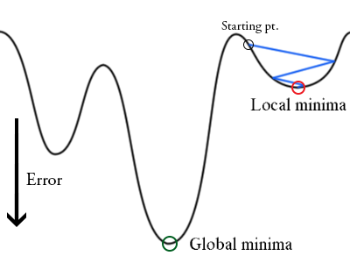

Depending on the initial starting point it is possible to never reach the best solution, but usually local minima is good enough according to experts in the field.

## Designing a NN.

Originally I’ve only received frequency data with two states – sharp and worn. FFT was already applied to it and the data was scaled. I’ve also used Ci Rong’s Mean Scatter Criteria function on it to obtain a visual representation of what Neural Network is supposed to recognize.

The below picture shows clearly the consistent difference in energy between sharp and worn tools. Left bottom is frequency domain data smoothed with a mean function (from 60000 data point to 6000). Top right is same data with 50 frequencies filtered using Class Mean Scatter Criteria function. It can be seen that the first 105 samples are of different lower energy (corresponding to sharp).

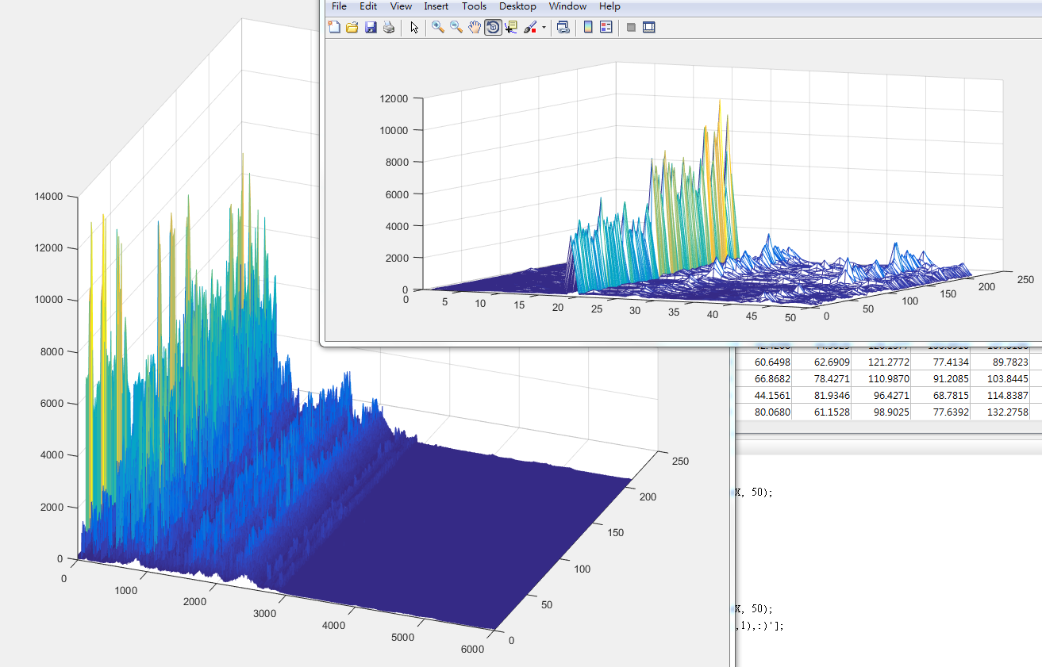

Understanding data structure is first step to designing a NN. It may not always be possible to visualise the pattern or even understand it. At minimum we must define number of input features and assign an outcome for supervised learning.

A simple NN is just a few matrix multiplications and pointwise parallel functions applied to the matrices. Inputs multiplied by weights, add bias, and apply activation function like sigmoid or ReLU (rectified linear unit) to get the next layer. Then the same for next layer. In code forward calculation looks like this:

h1 = sigmoid(ones.Append(X) * Theta1.Transpose());

out = sigmoid(ones.Append(h1) * Theta2.Transpose());

Where X is the input, Theta1 and Theta2 are weights and ones are biases.

## Python steps:

1. Understand data, if not able to analyse, know dimensions, number of inputs, outputs, desired classification.
2. Create model
3. # input variables denoting the features and label data
4. feature = C.input_variable(input_dim) # C. is CNTK
5. label = C.input_variable(out_classes)
6. # Instantiate the feedforward classification model
7. def create_model(features):
8. with C.layers.default_options(init = C.layers.glorot_uniform(), activation = C.ops.relu):
9. h = features
10. for _ in range(num_hidden_layers):
11. h = C.layers.Dense(hidden_layers_dim)(h)
12. r = C.layers.Dense(out_classes, activation = None)(h)
13. return r
14. z = create_model(feature)
15. # Another way (KERAS) to create the model, which is simpler:
16. # my_model = C.layers.Sequential ([
17. # Dense(hidden_layers_dim, activation=C.ops.relu),
18. # Dense(hidden_layers_dim, activation=C.ops.relu),
19. # Dense(out_classes, activation=None)])
20. # z = my_model(feature)

3.a Create loss and metric functions used to train the model

loss = C.losses.cross_entropy_with_softmax(z, label)

label_error = C.classification_error(z, label)

3.b Create learning parameters and learning algorithm used to train the model

# Instantiate the trainer object to drive the model training

lr_schedule = C.learning_parameter_schedule(learning_rate, minibatch_size=num_mb_iter) #C.learners.IGNORE

learner = C.sgd(z.parameters, lr_schedule) # stochastic gradient descent/minibatch descent

3.c Create trainer object that coordinates model training

trainer = C.Trainer(z, (loss, label_error), [learner], prog_printer)

4. Create reader stream that reads data in from .ctf file or load data into numpy array. Reader stream:

# Read a CTF formatted text using the CTF deserializer, from a .ctf file

def create_reader(path, is_training, input_dim, num_label_classes):

return C.io.MinibatchSource(C.io.CTFDeserializer(path, C.io.StreamDefs(

labels = C.io.StreamDef(field='labels', shape=num_label_classes, is_sparse=False),

features = C.io.StreamDef(field='features', shape=input_dim, is_sparse=False)

)), randomize = is_training, max_sweeps = C.io.INFINITELY_REPEAT if is_training else 1)

# Create the reader to training data set

reader_train = create_reader(dataPath_train, True, input_dim, out_classes)

# Map the data streams to the input and labels.

input_map = {

label : reader_train.streams.labels,

feature : reader_train.streams.features

}

z.save(model_output_file)

5. Loop the following:

- Get next data batch from the stream

- Pass the data to the trainer

Optional: Run test on unseen data from a different stream/array and determine accuracy periodically. If the number of samples is low, NN can easily overfit the data and can produce worse results on unseen data. This can be avoided is # of samples is high.

6. Save the best model.

To use the model in python, simply create data stream, load model, and run evaluation function.

z = C.load_model(model_file)

out = C.softmax(z) # assigns probability based values

predictions = out.eval({out.arguments[0]: features})